Preparing your home for a Live In Care Professional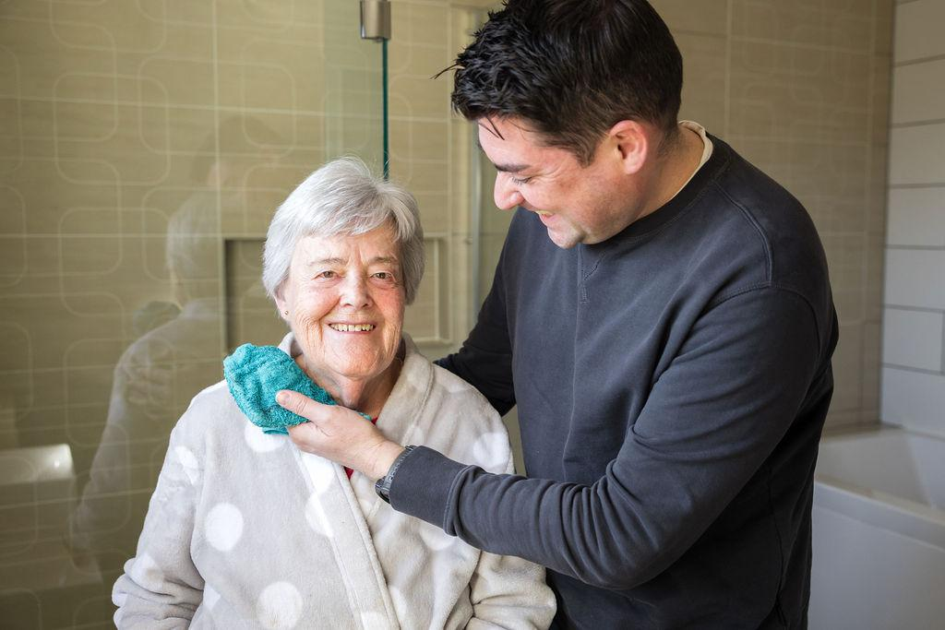
At Radfield Home Care, we understand that welcoming a live in Care Professional into your home is a significant step. It marks the beginning of consistent, tailored support designed to help you or your loved one remain safe, independent, and connected to the things that matter most. Preparing your home for live in care is about creating a safe, respectful and comfortable environment for everyone involved. It also ensures that care delivery is seamless and that the Care Professional can provide the best possible support.
We’ve created this guide to help you navigate the practical side of getting ready for live in care. Whether you're preparing for elderly care at home, recovering from an operation, or introducing long-term support for a loved one with complex needs, we’re here to help every step of the way.

Creating a comfortable and functional Space

Room setup for live in care
A live in Care Professional will require their own private room. This space should be clean, furnished, and offer comfort and privacy. While they are there to provide dedicated care, they are also living away from their own home, and it’s important they feel settled and respected. A welcoming and well-prepared room contributes significantly to the continuity and quality of care they’re able to provide.

A good room setup for a live in carer includes:
- A comfortable bed with suitable bedding.
- A wardrobe or drawer space for clothes and personal belongings.
- Power sockets for charging devices and access to good lighting.
- A bedside table and chair, if possible.
- Curtains or blinds for privacy.
- Access to Wi-Fi (if available).
If your home layout allows, a private bathroom is ideal. Where this isn’t possible, agreeing on a shared bathroom schedule ensures everyone feels comfortable.
In addition to the bedroom, the Care Professional will need reasonable space in shared areas to manage their daily routine:
- A dedicated shelf or section in the fridge and kitchen cupboards for their food.
- Access to basic kitchen appliances and space to prepare their own meals.
- A suitable area in the bathroom to store toiletries (if space allows).
- Use of laundry facilities and somewhere to dry or hang clothes alongside the client's.
These thoughtful touches help ensure your Care Professional feels respected in their role, which in turn supports a more harmonious and effective care relationship.

Privacy and live in care
Privacy is essential in any shared living arrangement. While your Care Professional is part of daily life, they are also a guest in your home and a professional delivering care. Establishing mutual respect and clear boundaries helps avoid misunderstandings and promotes a positive environment for everyone involved.
We recommend having open conversations about:
- Boundaries in shared spaces, such as when the Care Professional may wish to use the kitchen or living room independently.
- Quiet times or downtime when the Care Professional may want space to relax.
- Areas of the home that are considered private or off-limits for each party.
We’re here to help facilitate these conversations and encourage open communication throughout the placement. A member of the Radfield Home Care team can be present during the setup phase to help establish a respectful, comfortable, and sustainable arrangement from the very start.

Adapting the home for safety and accessibility

Home adaptations for older people and the differently abled.
Creating a safe and accessible home environment is a key part of preparing for live in care. During our initial consultation, we assess the home environment to identify any risks or changes that may improve mobility and safety.
Depending on the individual's needs, we may recommend adaptations such as:
- Handrails on stairs and in bathrooms.
- Bed rails or hospital-style beds.
- Anti-slip mats and clear walkways.
- Accessible seating.
- Raised toilet seats or grab bars.
- Personal alarms and fall detectors.
These small changes can make a huge difference to independence and reduce the risk of injury. If necessary, we can help coordinate with occupational therapists, district nurses, or local health services to implement these home adaptations.

Mobility support at home
If mobility is limited, ensuring that the home layout is easy to navigate is crucial. This might include:
- Removing trip hazards such as rugs or loose wires
- Ensuring furniture allows for clear paths
- Widening doorways for walking aids or wheelchairs
- Placing everyday essentials within easy reach
Your Care Professional will also assist with daily mobility and transfers using appropriate moving and handling techniques. These measures protect both the client and the Care Professional, ensuring care is delivered safely.

Establishing daily routines and schedules

Coordinating care with family involvement
Live in care is deeply personal. One of its key strengths is that support is provided in the comfort of your own home and can follow familiar patterns and routines. We work closely with you and your family to build a care schedule that feels natural and respectful of how you like to live.
Together, we’ll create a daily rhythm that may include:
- Mealtimes and dietary preferences.
- Medication schedules.
- Personal care routines.
- Social activities and outings.
- Hobbies and interests.
- Time for rest and relaxation.
We’ll also take the time to understand the little things that matter - whether it’s how someone likes their tea, their favourite radio show, or when they enjoy reading the paper. These personal details help our Care Professionals build trusting and lasting relationships.
Family involvement in care is always welcome, and we’ll keep you informed and engaged through regular updates via our digital care management system. This enables shared visibility of the care being delivered and supports collaborative decision-making when needs evolve.

Introducing the Care Professional and the Radfield Team
Before care begins, we match you with a live in Care Professional based on their experience, personality and your specific care needs. Whenever possible, we offer an opportunity for you and your family to meet the Care Professional ahead of time. This can be a helpful moment to ease any concerns, ask questions, and build confidence before care begins.
Importantly, every live in Care Professional is supported by our wider Radfield Home Care team. Behind the scenes, your local care management office will be coordinating referrals, supporting with medication arrangements, and offering emotional and practical support to both the person receiving care and their loved ones.

Respecting the Care Professional’s space and boundaries
While the focus of live in care is on the individual receiving support, it’s essential to remember that Care Professionals are living and working in the home. As such, they require a private room of their own for rest, privacy, and downtime.
We kindly ask families to ensure that this room remains private and undisturbed at all times, even when relatives or guests come to stay. For example, it would not be appropriate for a family member to share the Care Professional’s room or use it for other purposes.
If you plan to host visitors or have a family member stay over, please let us know in advance. This allows us to assess whether the care schedule or environment needs adjusting to maintain both the client’s wellbeing and the Care Professional’s working conditions.
Likewise, it’s important to recognise that live in Care Professionals are there to support the individual receiving care - not the wider family or household. If additional support is required during busy family periods or events, we can help you explore extra care options to ensure everyone’s needs are met in a respectful, safe and sustainable way.

Making your home a safe and welcoming care environment

Safe home for carers and clients alike
Creating a home care environment that works well for both client and carer requires planning and ongoing support. We carry out a full risk assessment and care planning process before care begins, and revisit this regularly as needs change.
Our Care Professionals are trained to observe and report any changes in health, wellbeing or home safety, and our local care management team is available to respond quickly if support is needed.
Families can expect clear communication, shared access to daily care notes, and transparency in everything we do. This open approach is key to maintaining high standards and trusting relationships.

Preparing for live in care: Final tips
As you prepare your home for a live in Care Professional, here are a few final suggestions:
- Make a list of emergency contacts and keep it visible.
- Ensure medication is stored safely and labelled clearly.
- Share a weekly planner or calendar with key events.
- Let neighbours or friends know about the new care arrangement, if appropriate.
- Take time to talk to the Care Professional about routines, preferences, and shared goals.
Live in care is a partnership; and good preparation ensures everyone starts off on the right foot.

Ready to take the next step?
At Radfield Home Care, we are here to guide you through every stage of live in care - from initial questions to settling into a new routine. If you're preparing for live in care and want a smooth, supported transition, we offer free, no-obligation care consultations, and we’ll walk you through every step with warmth, honesty and practical guidance.
For more advice or a free consultation, please contact your local Radfield office.

